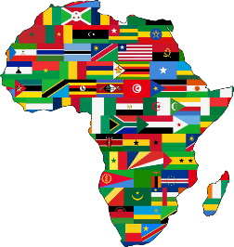
𝙴𝚖𝚋𝚛𝚊𝚌𝚒𝚗𝚐 𝙳𝚒𝚟𝚎𝚛𝚜𝚒𝚝𝚢 𝚈𝚘𝚞𝚝𝚑

𝐑𝐄𝐆𝐈𝐒𝐓𝐑𝐀𝐓𝐈𝐎𝐍 𝐅𝐎𝐑𝐌

Date:
Name:
Email:
Gender:
Date of birth & Age:
Mobile Number:
Address:
Preferred Contact method : Email / Mobile / Facebook Other (please indicate)
Tshirt Size: XXS / XS / S / M / L / XL Colour: White / Yellow / Black / Red / Green
Ethnicity and Languages spoken:

Any medical conditions, allergies, dietary requirements:
Emergency contacts:
Name and Contact Number: |  | Relationship:
Name and Contact Number: |  | Relationship:
Emergency Contact if main contact people cannot be reached:
Name: |  | Mobile:
What activities do you hope to participate in while in the group, please do not limit yourself:
Days / Times that will work best to attend Events:
Please read the Privacy Assessment Statement (overleaf) and indicate your acceptance by signing below:

If under 16 please get your parents to sign below: We are happy to answer any questions parents have in regards to the programme.
Name of parent
Sign here to allow consent for your child to register.
Would you like to have a role in the development of the program: yes/no

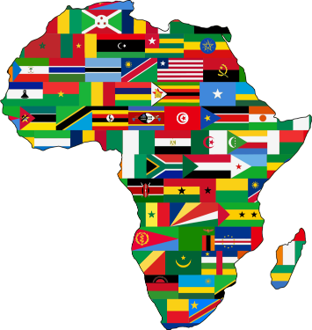
Embracing Diversity Incorporated
Privacy Statement

We ask for and collect information from you such as you and your child’s Name, Address and Contact details. We do this to allow us to keep you updated or to enable us to contact you about upcoming Embracing Diversity activities.

We may also ask you for other information, such as Ethnicity and Languages spoken. It is up to you whether you provide this, however if provided it may help us ensure we focus our efforts and plan our activities approriately.

Additionally we need to know who you authorise for us to contact in emergency and if you have any special needs, requirements, medical conditions, allergies and special dietary requirements

Embracing Diversity will be the only recipient of this information. All collected information will be held securely by the Embracing Diversity committee, and may include images, voice or video recordings of yourself that have been obtained during scheduled events.

How we use your Information
Embracing Diversity will use the information collected for the purpose of communicating with you (for example: seeking your views or sending you newletters) or ensuring your well-being and safety are protected.
We will never share any of the information you provide with another party.
If any of your details change, or you no longer want us to hold your details, please advise us by emailing contact@embracingdiversity.co.nz

Social Media
You agree that you will not take photos or videos of other people and post them publicly (e.g. onto social media) without their consent. Embracing Diversity will always ask for your permission before using any images that include yourself on our website, social media pages, newsletters or emails.

